- Go to www.texasassessments.com

- You will see a screen like this:

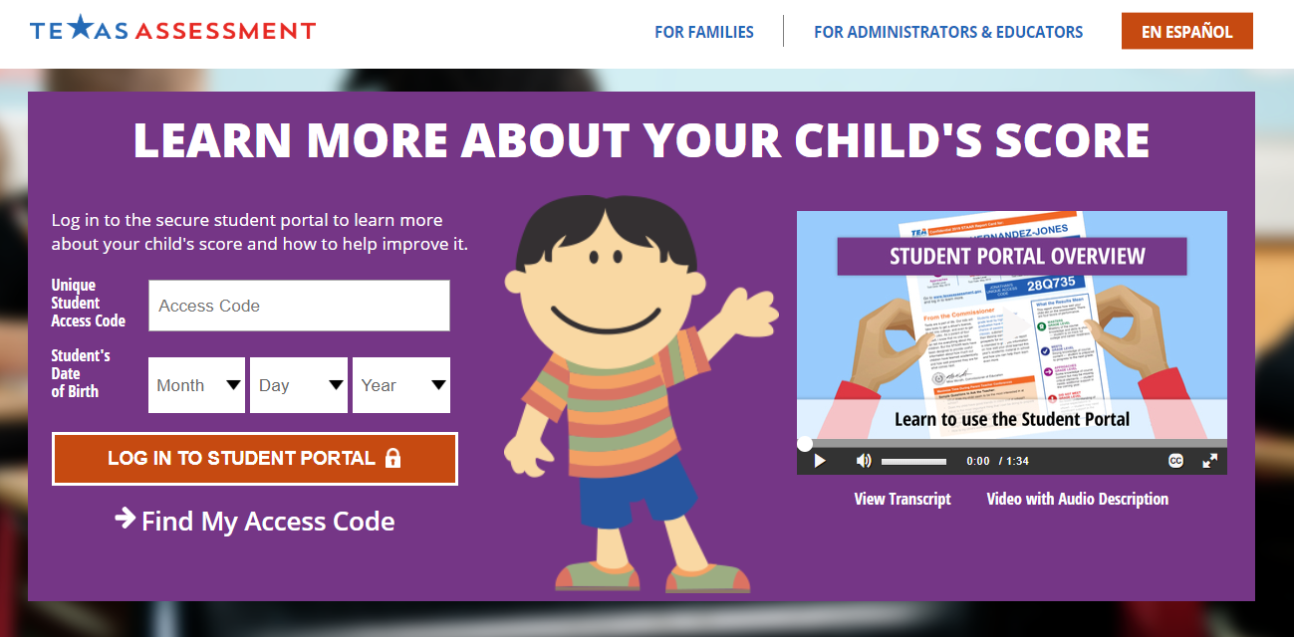

3. If you have your access code, enter the code and your child’s birthdate and click “log in to student portal” to view scores.

4. If you do NOT have your access code, click on “Find My Unique Student Access Code” link.

5. You will then see a screen like this:
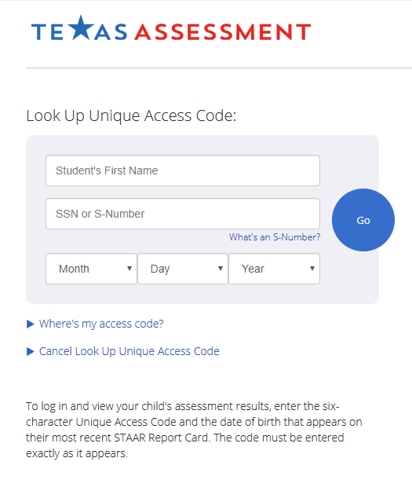

6. Enter your child’s first name only and his or her social security number in the SSN or S-Number Field, and birthdate. Then click the blue “Go” button.

7. Your access code will appear in the code field with a message saying, “Access Code Lookup Successful”. Click the blue “Go” button again to see your child’s scores. Be sure to write down your access code for future use. The code is good for as long as your child is in a public school in Texas.

STAAR results will be available on the following dates:
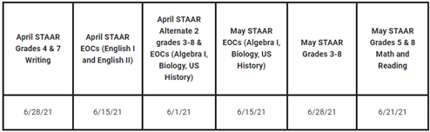

TELPAS
7/19/21

